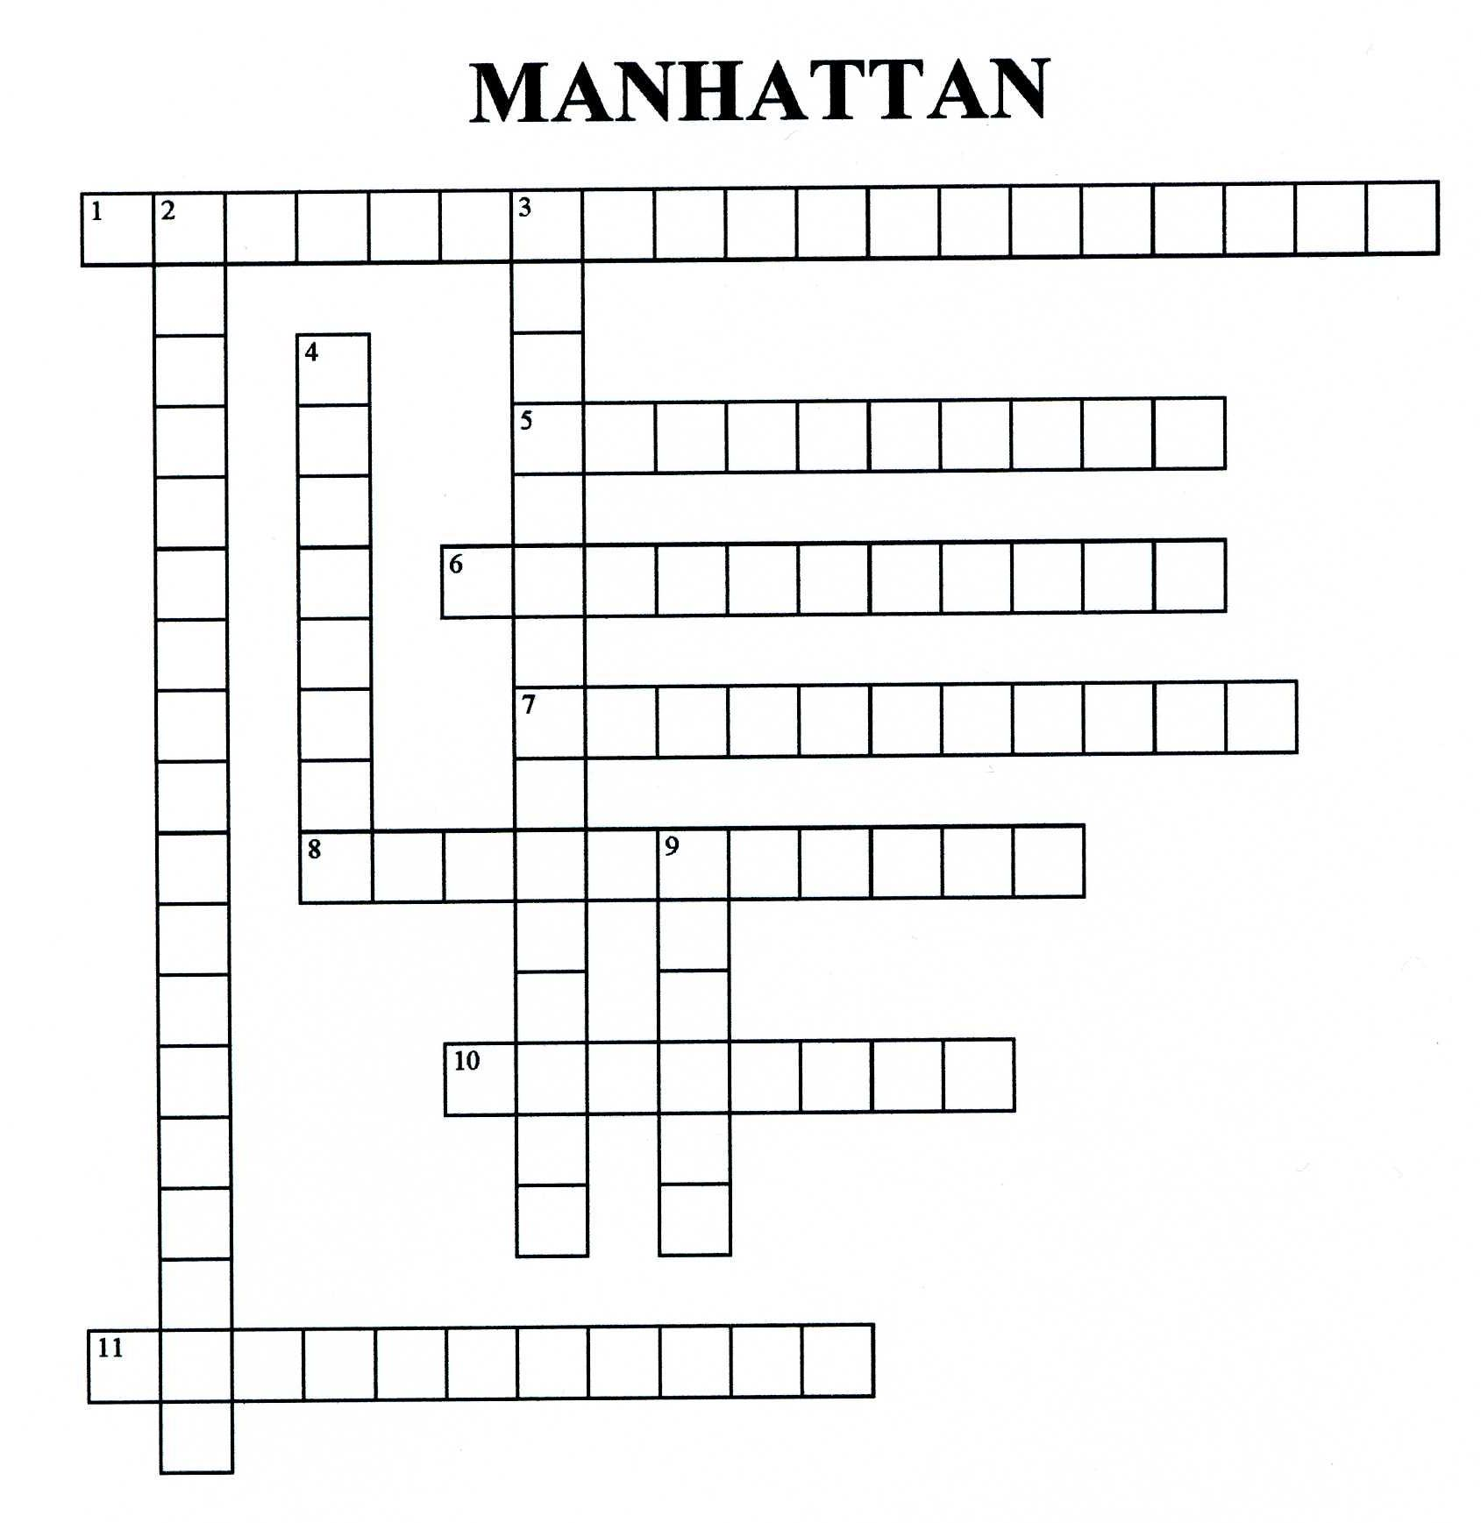
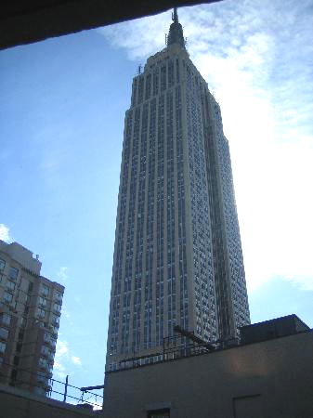
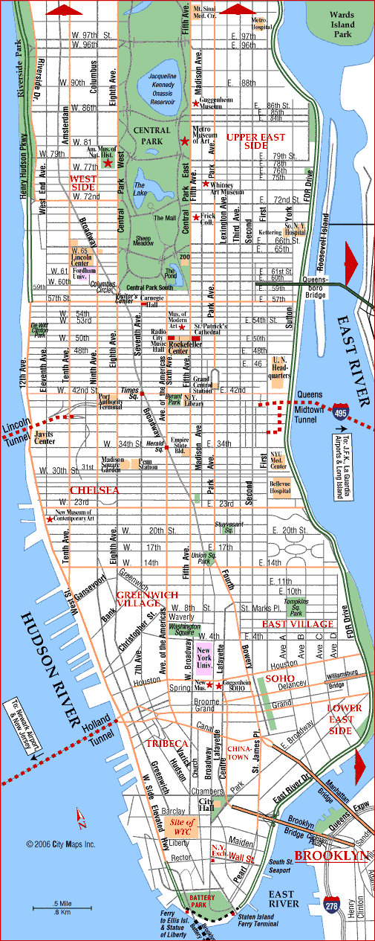
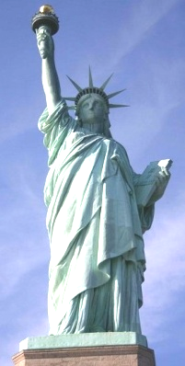
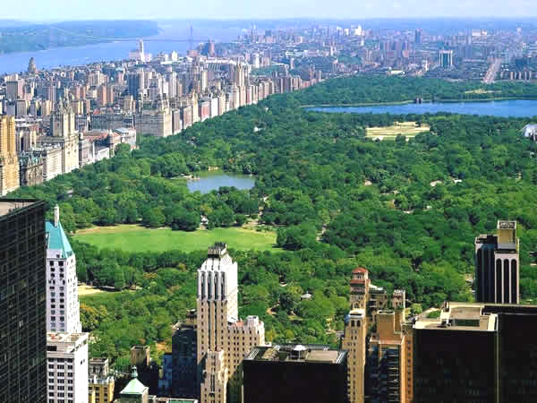
ACROSS | DOWN
1 The highest skyscraper in Manhattan | 2 A great art museum
5 Destroyed on 9/11/201 | 3 a gift from France in 1886
6 A huge park | 4 New-York’s nickname
7 This street is famous for shopping | 9 Manhattan is an ….
8 The island where immigrants arrived
10 This street is famous for its musicals
11 Manhattan is between the East river and the…

Thanks to the pupils of 5C and 5E

